

SCHOOL *of* BUSINESS AND TECHNOLOGY

Department of Engineering and Aviation Sciences

**Design of a VR Game-Based Learning Application**

**Zachary Allen**

Advisor: Dr. Zhang

Started: March 3, 2019

Design of a VR Game-Based Learning Application

By

Zachary Allen

Submitted to the Department of Engineering and Aviation Sciences in partial fulfillment of the requirements for the degree of Bachelor of Science in Engineering at the

UNIVERSITY OF MARYLAND EASTERN SHORE

Date

The author hereby grants the University of Maryland Eastern Shore permission to reproduce and distribute publicly, paper and or electronic copies of this document in whole or in parts.

Authors Zachary Allen

Signature

Date

Department of Engineering and Aviation Sciences

Certified by

List of Contents

List of Contents 3

List of Figures 5

List of Tables 6

Abstract 7

1. Introduction 8

1.1 Backgound/Motivation 8

1.2 Objective 10

1.3 Design Requirements 10

1.4 Design Constraints 10

1.5 Design Approach 10

1.6 Standards 11

2. Project Description 12

2.1 System Description 12

2.2 System Diagram 12

2.3 System Functions 12

3. Implementation Plan 14

3.1 Tasks 14

3.2 Team Organization 15

3.3 Timeline/Milestones/Delivery Plan 15

4. Implementation 16

4.1 Implementation of Task 1. 16

4.1.1. Implementation of Subtask 1A 16

4.1.2. Implementation of Subtask 1B 16

4.1.3. Implementation of Subtask 1C 17

4.2 Implementation of Task 2. 17

4.2.1. Implementation of Subtask 2A 17

4.2.2. Implementation of Subtask 2B 18

4.2.3. Implementation of Subtask 2C 19

5. Conclusion (Discussion and Future Plans) 20

Acknowledgment 21

Appendix 22

A. Component Specs 22

1. Specs of Arduino Due 22

2. Specs of Raspberry Pi 22

B. Source Code. 22

1. Source Code of Graphic User Interface 22

2. Source Code of Robotic Arm 22

REFERENCES 23

List of Figures

Table 1. Project Timeline and Delivery Plan 9

List of Tables

Abstract

By the end of the project, summarize the project into short text and put here.

1. Introduction

This project will utilize virtual reality and game-based learning to create an ominous puzzle game with shooter elements akin to Call of Duty. The end goal of this project is to provide a game that both allows the players to learn elements taught in a digital-logic circuits class room and give them time to unwind battling braindead enemies hindering their progress.

## Backgound/Motivation

For some, video games are a hobby in their everyday lives. Whether they are playing games to relieve themselves from stress after a long day; learn something new; or to entertain an audience on the internet, the video game market can provide enjoyment for just about anyone. Ultimately, the purpose of video games is to provide fun, enjoyment, and replayability for the consumers. Video games can also serve as a means to bring various people together like shown in Figure 1. People from various backgrounds can come together through a single hobby they enjoy.



Figure - People Playing a Game Together

For others, video games are long, strenuous projects that must be built as a development team for consumers to buy. In an ideal world, developers would work throughout the week with little overtime and no development crunch to release the right game for the right audience. Of course, even a released video game does not get produced perfectly. Issues may pop up after the video game reaches the shelf.

Today, video games are constantly being patched. Patches in video games serve two major purposes: fix existing bugs and/or add more content. Bug fixes typically come as a result of consumer feedback. The consumer can provide bug reports to the developers to tell them what is not working properly. These reports serve as a basis for a “bug fix patch.” However, this process remains throughout the game’s shelf life. Often times, fixing one bug could expose another bug and so on and so forth.

Game patches can also add content to the game itself. This practice has existed since the era of MMORPGs (Massively Multiplayer Online Role-Playing Games) where patches would add content for players of all levels and even expand upon the base game with expansions. Today, add-on patches end up serving as an excuse to release games unfinished, effectively time-gating the content to artificially increase the shelf life of a game. The best developers to follow utilize patches to fix bugs as they get reported and provide additional content that is not mandatory for the base game but enhances the game for better enjoyability.

While some video game developers are major corporations creating high-budget games designed to bring in a lot more money then what went into the game, others are small teams of people creating a passion project to share to the world. No matter who the developers are, most video games are crafted with care, attention, and intent to produce an impact on their fans. With the introduction of more efficient video game crafting tools, anyone can join the video game development with the right amount of practice and dedication.

For instance, one tool people could use to create video games is Unity. The unity website provides a free version for anyone to get started with and more advanced versions should they decide to make a career out of producing games. Unity also provides an asset store for people to use to help craft their game to suit their big design. They also have an active forum and classes to help aspiring developers learn the system and produce a game in no time.

Suppose someone wanted to create an edutainment game on Unity. Some people may think to themselves, “Why bother? Are these games only meant for young kids?” On the contrary, edutainment games do not have to be restricted to just the young. There is a potential market to bring such video games to high school and even college. A game can be made to teach more advanced concepts while providing moments to turn off their brains after thinking on a puzzle for so long.

Perhaps an immersive video gaming experience could help breathe new life into edutainment video games. With virtual reality technology breathing new life and brimming with more potential than ever before, edutainment games could seek a new home in VR gaming. All they would need is a VR headset like the one shown in the figure below. This surging technology could provide more means to teach students more educational subjects than ever before while including breaks from learning.

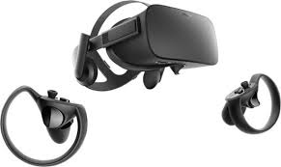

Figure - An Example of a VR Headset

This idea of combining video gaming with education is called game-based learning, also known as GBL. An example idea of a game-based learning application is to use a puzzle game similar to the 3D *Legend of Zelda* games combined with a shooter game such as *Call of Duty*. This combination allows the player to solve puzzles teaching various concepts taught in class such as a class on circuitry while also letting them unwind between puzzles by mindlessly shooting down enemies. Ideally, the GBL application would have an equal mix between shooting and learning so the player is learning without being burnt out from just learning without a moment to relax.

## Objective

The overarching goal of the project is to create a game for engineering students learning digital logic circuits that both teaches them elements of the class and engages them in the game world.

## Design Requirements

The game will take about half an hour to complete. There will be characters and objects to interact with. These interactions are either chatting with friendly NPCs, knocking out enemies, or using objects available to complete a given puzzle. The game itself will have 4 puzzles to solve with permanent rewards for each puzzle to assist the player. The game will also utilize teleportation to work over the limited play area virtual reality provides. The game will end with a 5-question quiz that will serve as the endgame. Essentially, this design will result in a puzzle + shooter action game with unnerving elements throughout.

## Design Constraints

The virtual reality technology provided by the institution provides the biggest restraint in this project. The labs utilize the HTC Vive virtual reality headset; and therefore, the game must run with this headset in mind. The headset itself is wired, so the game must be built to provide functions to work over the limited play area as in the SteamVR’s teleportation feature.

Because of the nature of virtual reality gaming, prolonged exposure can result in headaches. This will severely limit the duration of the game itself. Considering this restriction, the game’s duration ended up being about 30 minutes.

## Design Approach

The design for this game is split into three intertwined parts: the story, the world, and the puzzles. Without a story, there is no reason for the world to exist. Without the puzzles, there is no reason to create this game utilizing GBL. Without the world, there is no game to begin with. In order to create the game, the story must be established.

In this case, the story involves the player winding up deep within an engineering facility. They must get a feel of their situation and try to escape the facility. Along the way, the player will encounter two types of enemies. The first are the previous people who were rendered braindead from struggling to solve the puzzles. The second are the security guards sent by the facility’s boss as a result of fear for the facility’s secrets being exposed. After being confronted by the boss, the player will be challenged to one last quiz and then sent to an unknown facility somewhere in space.

The world is developed based off the story. The world takes place within a hidden testing chamber of an engineering facility. The facility was purposed to teach their trainees digital logic circuits. However, years have passed, and no one has solved all four of its puzzles. These trainees have become braindead and with attack anyone who gets in their line of sight. Over time, the player will learn than the facility is holding a secret the boss does not want to have leaked. The boss will send security to stop the player the closer they are to the end.

From there, the basis for what the player will see can be made. There will be a visible health bar with the health having a max value that increases twice throughout the puzzles. The puzzles will also award players with two weapon upgrades just in time for the elite enemies towards the end. Because of the limited movement space, the player will also be allowed to teleport to bypass this limitation. Since each room and hallway will be its own scene in Unity, each time a new scene is loaded, that scene will become the respawn point should the player lose their health points. The approach will be highlighted in the figure below taking all the points from this section of the report into consideration.

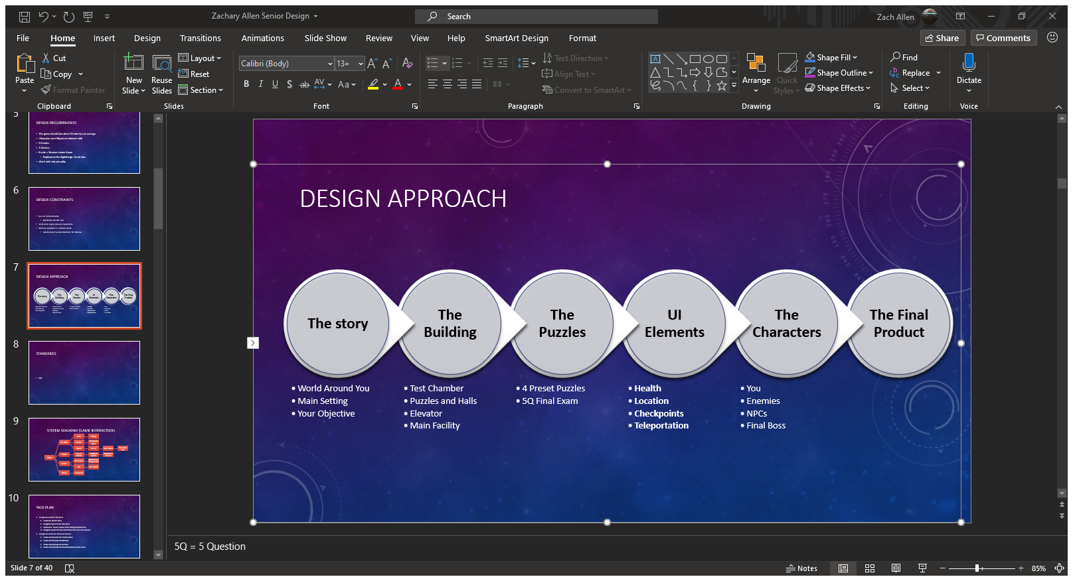

Figure - Design Approach

## Standards

There are no standards the project must comply with.

1. Project Description

## System Description

This game will utilize Unity and virtual reality. The player’s movements combined with their controller inputs dictate how the game is controlled. There will be button inputs for helping with puzzles, beating down enemies, and teleporting around rooms larger than the VR play area.

## System Diagram

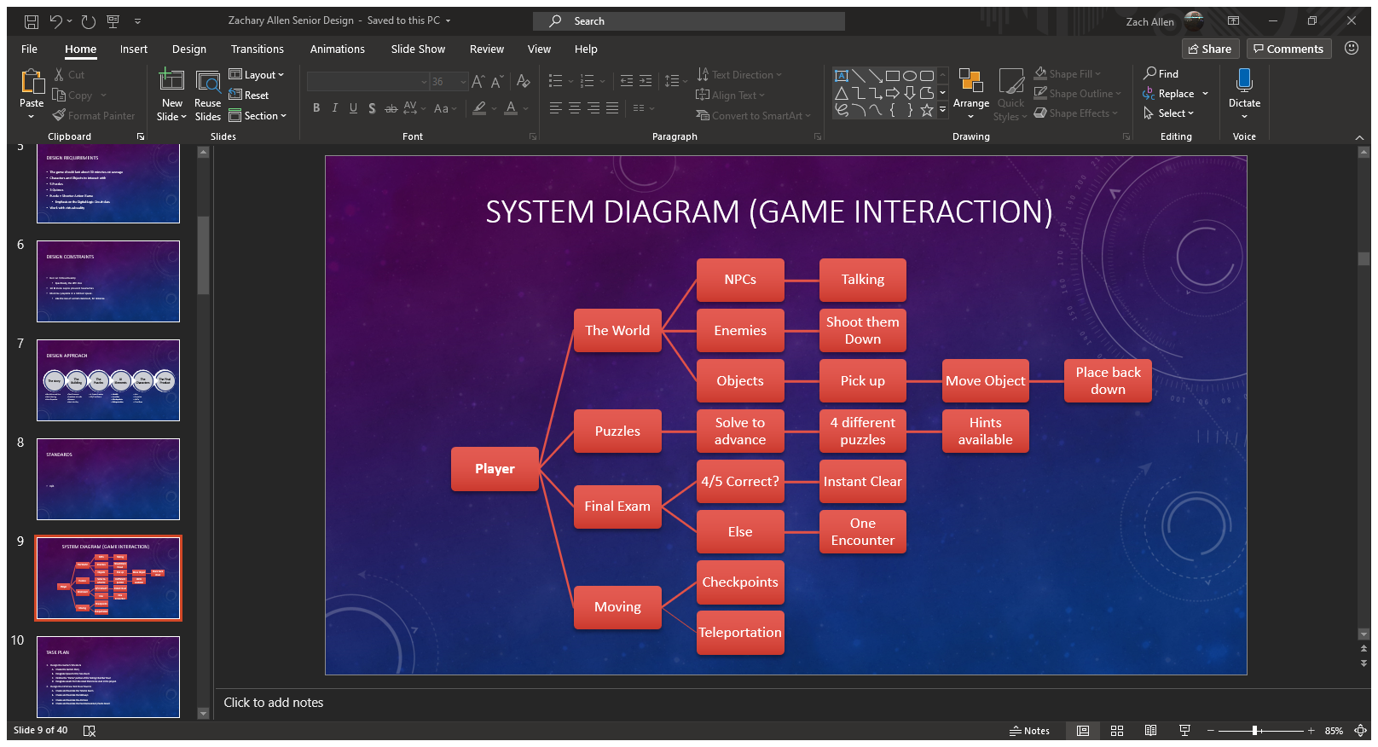

Figure - The Game's System Diagram

## System Functions

The game will feature four different interactions that are intertwined throughout the game. For interactions with the world, the player can either talk with friendly NPCs, take out enemies before they are taken out themselves, or interact with specific objects to move them around the play area. Other objects are dropped by enemies to help recover any damage taken throughout the adventure.

Puzzle interactions are simple. The player must clear each of the four puzzles to continue. A hint will be provided for each puzzle to guide the player in the right direction. After clearing the puzzle, the player will be rewarded with upgrades whose potency is based on completion time with faster puzzle solving leading to better rewards.

After solving the puzzles, the player will be placed under a Final Exam by the antagonist. There will be 5 questions that change be changed in the main menu by the professor. The player must answer 4 of the 5 correctly to clear the game. Otherwise, they must face 3 elite enemies and defeat them to clear the game.

Movement is a critical aspect of this game. While the player can move around freely, the world will be larger than the play space virtual reality allows. To compensate, the player will be allowed to teleport throughout the world. There will also be a system to load the player back to the beginning of whatever room they are in to prevent having to start from the first room after each death.

1. Implementation Plan

## Tasks

* Task 1: Design the Game’s Foundation
  + Subtask A: Develop the Game’s Plot
  + Subtask B: Establish the Game’s Structure
  + Subtask C: Designate Assets to Create the Project
* Task 2: Design the Hallways of the Game
  + Subtask A: The Starting Room
  + Subtask B: Basic Hallways
  + Subtask C: Advanced Hallways
* Task 3: Design the Puzzle Rooms
  + Subtask A: Decimal to Binary
  + Subtask B: Boolean Algebra
  + Subtask C: K-Map
  + Subtask D: D Flip Flop
* Task 4: Create the Game’s UI Elements
  + Subtask A: Enable Teleportation
  + Subtask B: Create a HP System
  + Subtask C: Establish Interactivity with the Objects
  + Subtask D: Make the Checkpoint System
* Task 5: Design the Game’s Enemies
  + Subtask A: Braindead Trainees
  + Subtask B: Regular Security Patrol
  + Subtask C: The Boss’ Elite Guard
* Task 6: Create the Main Lobby
  + Subtask A: A Live Office
  + Subtask B: The Final Exam
* Task 7: Verify the Program
  + Subtask A: Ensure Every Event Works Properly
  + Subtask B: Ensure Each Scene is Loaded One After Another
  + Subtask C: Debug the Game

## Team Organization

This project will be completed by one person. As such, Zachary Allen will be solely responsible for the completion of each task shown in the timeline. The timeline below shows what is to be expected after each week until it is time for the final presentation

## Timeline/Milestones/Delivery Plan

1. Project Timeline and Delivery Plan

|  |  |  |
| --- | --- | --- |
| Week | Tasks | Details |
| 1-2 | 1A, 1B, 1C | Create the Foundation for the Game |
| 3-4 | 2A, 2B, | Design the Hallways between Puzzles |
| 5 | 2C | Create the final hallways |
| 6-7 | 3A, 4A, 4C | Start the Puzzle Room and UI Elements |
| 8-11 | 5A | Create the First Enemy |
| 12-14 | 4B, 4D | The Rest of the UI is made |
| 16-18 | 3B, 3C, 3D | The Other Puzzles are developed |
| 19 | 5B, 5C | The Harder Enemies are made |
| 20 | 6A, 6B | Create the endgame |
| 21-22 | 7A, 7B, 7C | Verify that the entire game works. |

1. Implementation

This section of the report will go through each task mention and how they have been implemented throughout the project.

## Implementation of Task 1.

This task is meant to develop the cornerstone for this entire game. This means the story, structure, and assets used are determined in this task. By establishing a foundation for the game, the rest of the tasks can follow suit as the game is being developed.

### Implementation of Subtask 1A

This task established the plotline for this game. For this adventure, the player is a trainee who got trapped within the facility’s training chambers. The player wakes up and must try to leave the chamber. They will solve the facility’s digital logic circuit puzzles and take down other trainees who became braindead throughout the testing process. As the game goes on, the player will learn that the antagonist did not mean for anyone to clear the chambers and will start to send his security personnel to stop the player. After confronting the boss and clearing his final exam, the player will be sent away so the boss’ secrets can remain hidden from public eye. Where the player ends up is the basis for another GBL Senior Design Project involving puzzles in circuits.

### Implementation of Subtask 1B

Now that the game’s story is set, the task to develop the game’s structure is afoot. Originally, the game would take place in one large chamber with winding hallways connecting to each puzzle room like shown in the figure below. However, this idea was eventually scrapped after realizing the player could not realistically navigate a large, winding facility.

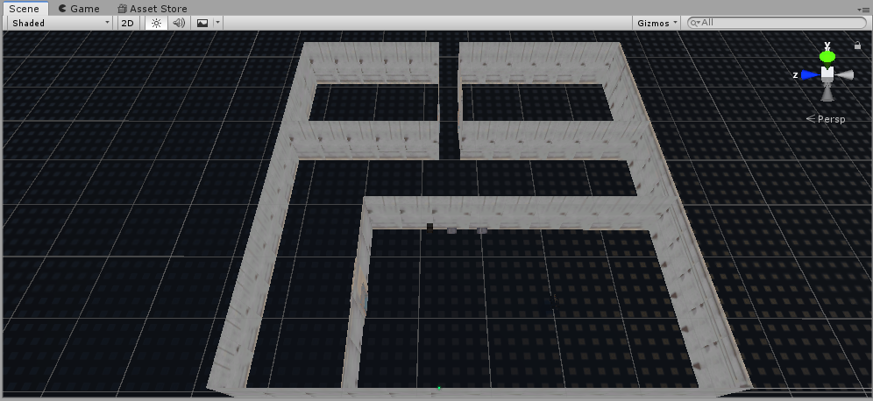

Figure - The Game's Original Structure

Therefore, the game took on a new structure. This structure takes full advantage of loading scenes in and out while compensating for the limited virtual reality movements. Each room, therefore, became its own scene in the final project with a script loading between each room as the player leaves the room before. This also includes the hallways connecting each room. Therefore, teleportation must be used as explained later on in the Implementation section.

### Implementation of Subtask 1C

With the story and structure of the game established, the time came to establish the assets the project will use. All of the assets will be mentioned in the Acknowledgements section with credit to their creators. One important asset to mention, however, is the SteamVR asset. This asset allows this project to run through its full potential with enabling this game to run in virtual reality. This asset almost makes movement through larger rooms possible with teleportation.

## Implementation of Task 2.

This task begins building the rooms the facility will go through. To start things off, the player will begin in the first room of the facility and will then go through a dark hallway to get to the first puzzle. With the structure being room then hallway and then room and so on, the first step would be to create the first room and the hallways to navigate.

### Implementation of Subtask 2A

The game begins in a surprisingly lit room deep inside the testing chambers. In the lore, these rooms are where trainees begin to complete their run through the facility to clear each puzzle. Such a room is implemented as shown in the figure below. The player will use this room to get familiar with the controls and proceed to the first hallway once acclimated with the controls.

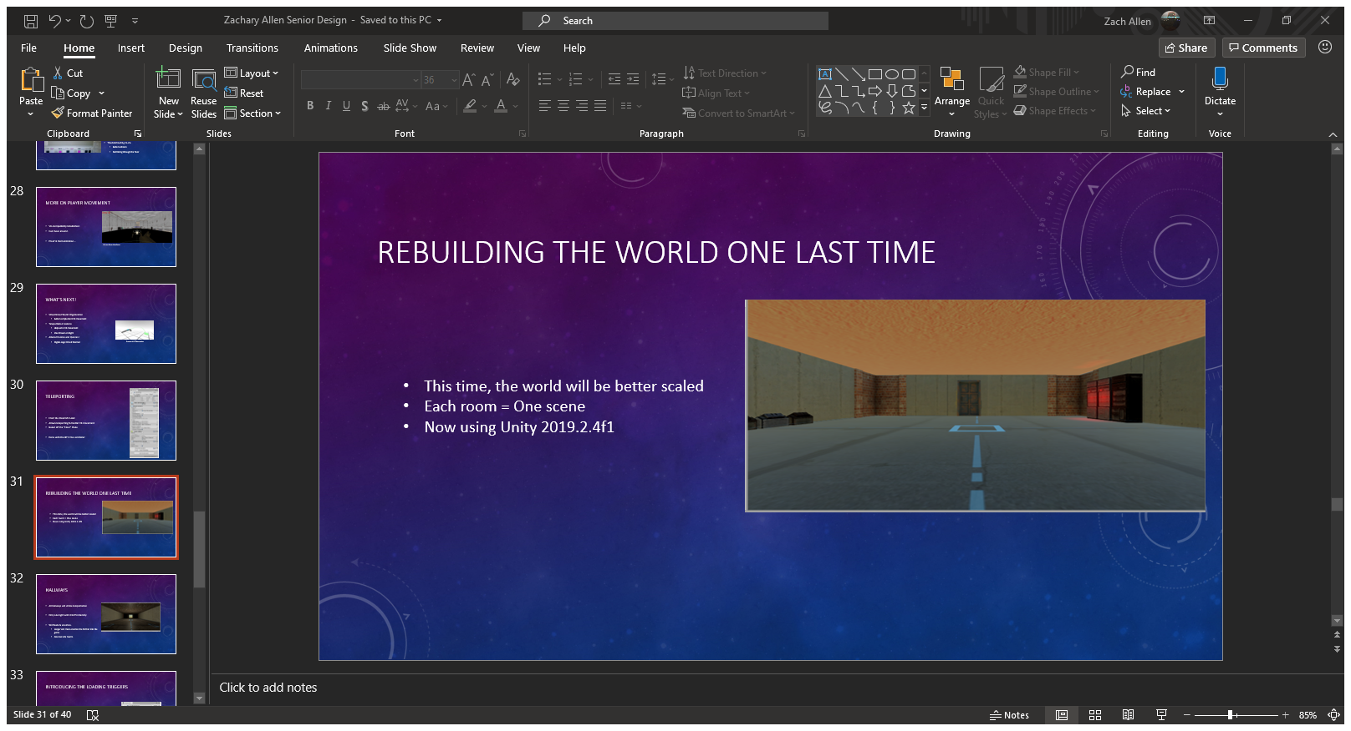

Figure - The First Room

### Implementation of Subtask 2B

Once the first room was built, the next objective was to create the 5 total hallways the game will have. There will be 3 simple-to-navigate hallways and 2 more advanced ones as the game progresses. This subtask focuses on the first 3 hallways. The first hallway is shown in the caption below. This room is very dark compared to the starting room and introduces the player to the first enemy of the game. However, this hallway is short, and the player can easily circumvent the enemies.

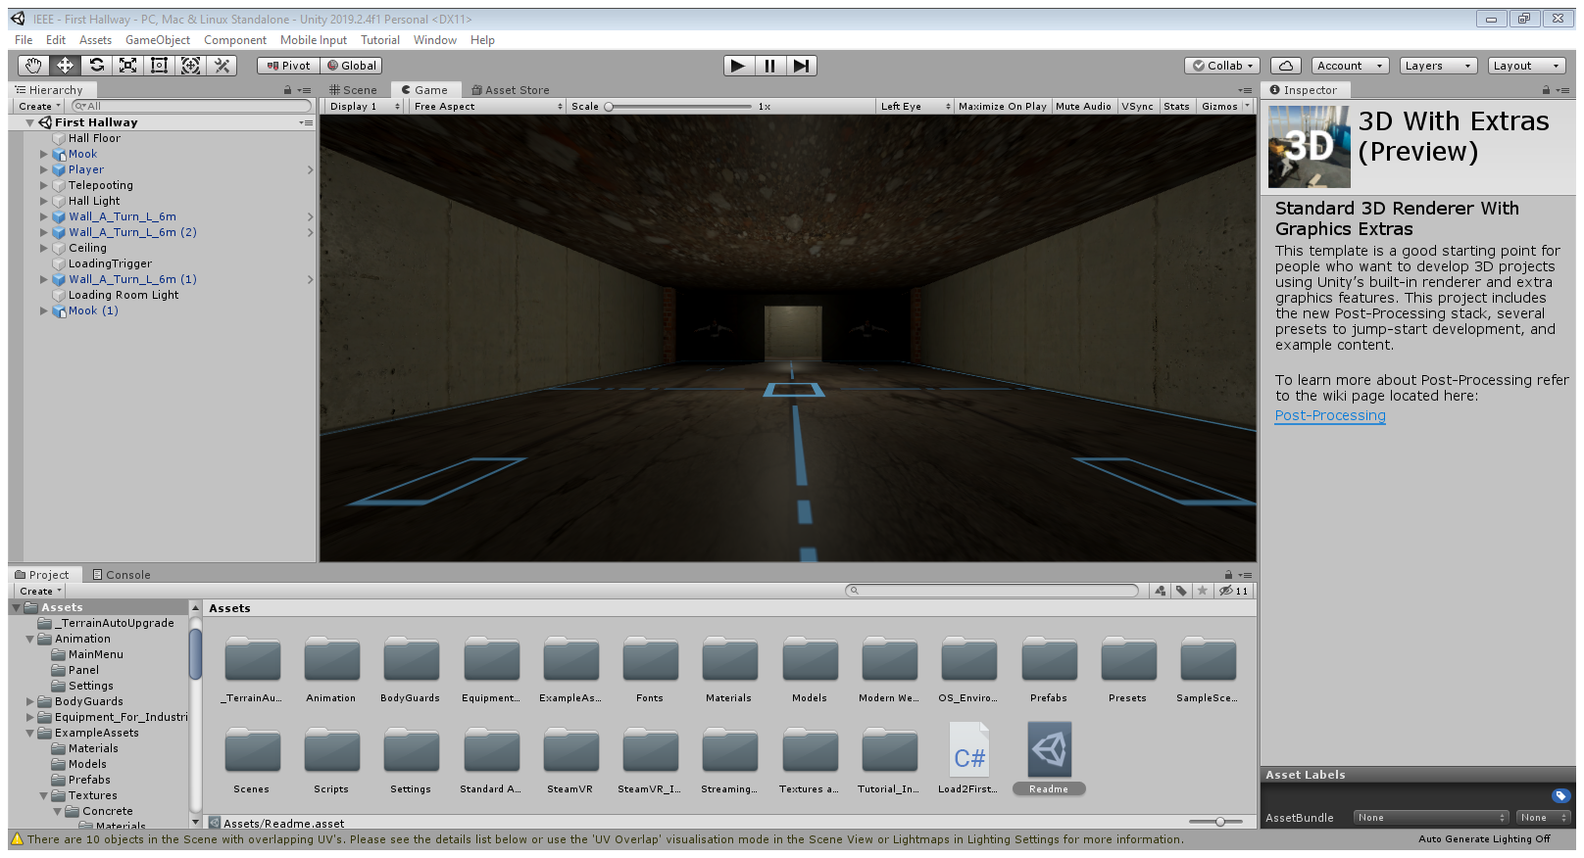

Figure - First Hallway

The second hallway is shown in the next figure below. This hallway is longer than the first one and even has an outdoor view. Like the first hallway, this one is a straight shot from point A to point B to get to the next puzzle.

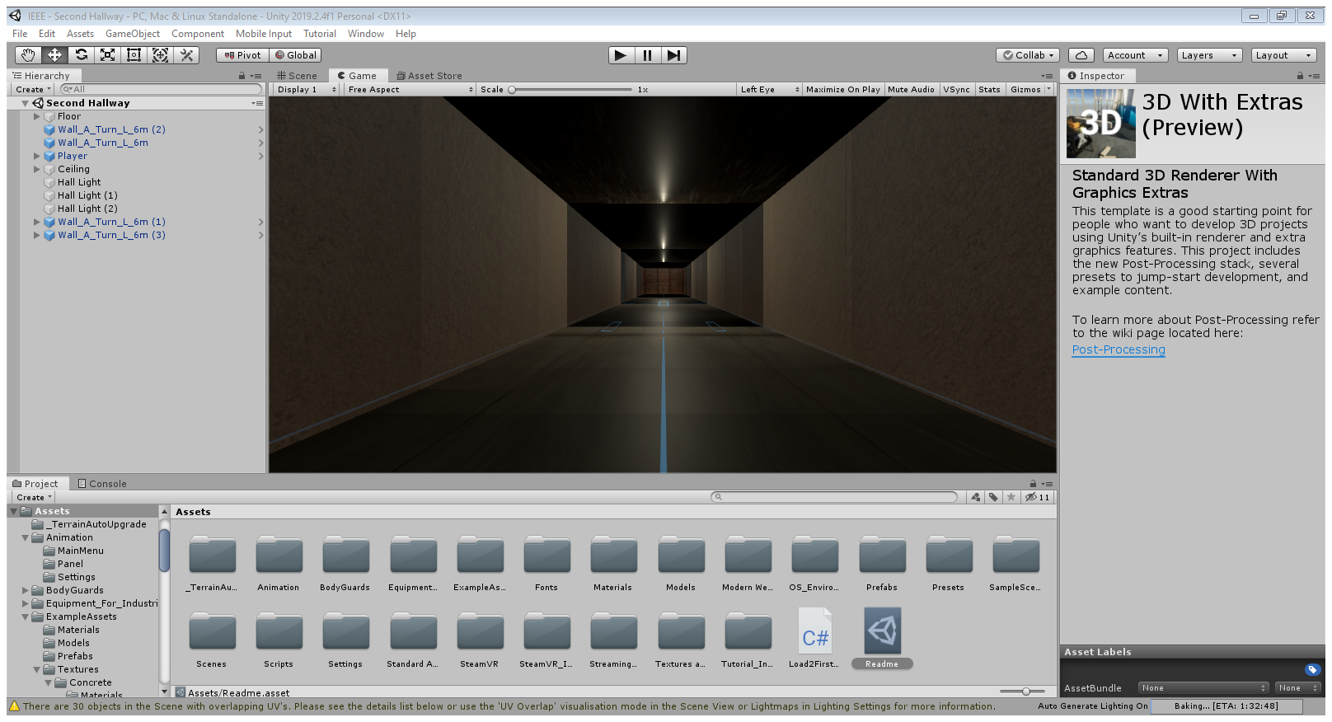

Figure - Second Hallway

The last simple hallway is shown below. This one bends at a 90-degree angle. This hallway will introduce the second enemy type of the game where the story escalated to the boss starting to actively keep the player in the testing facilities.

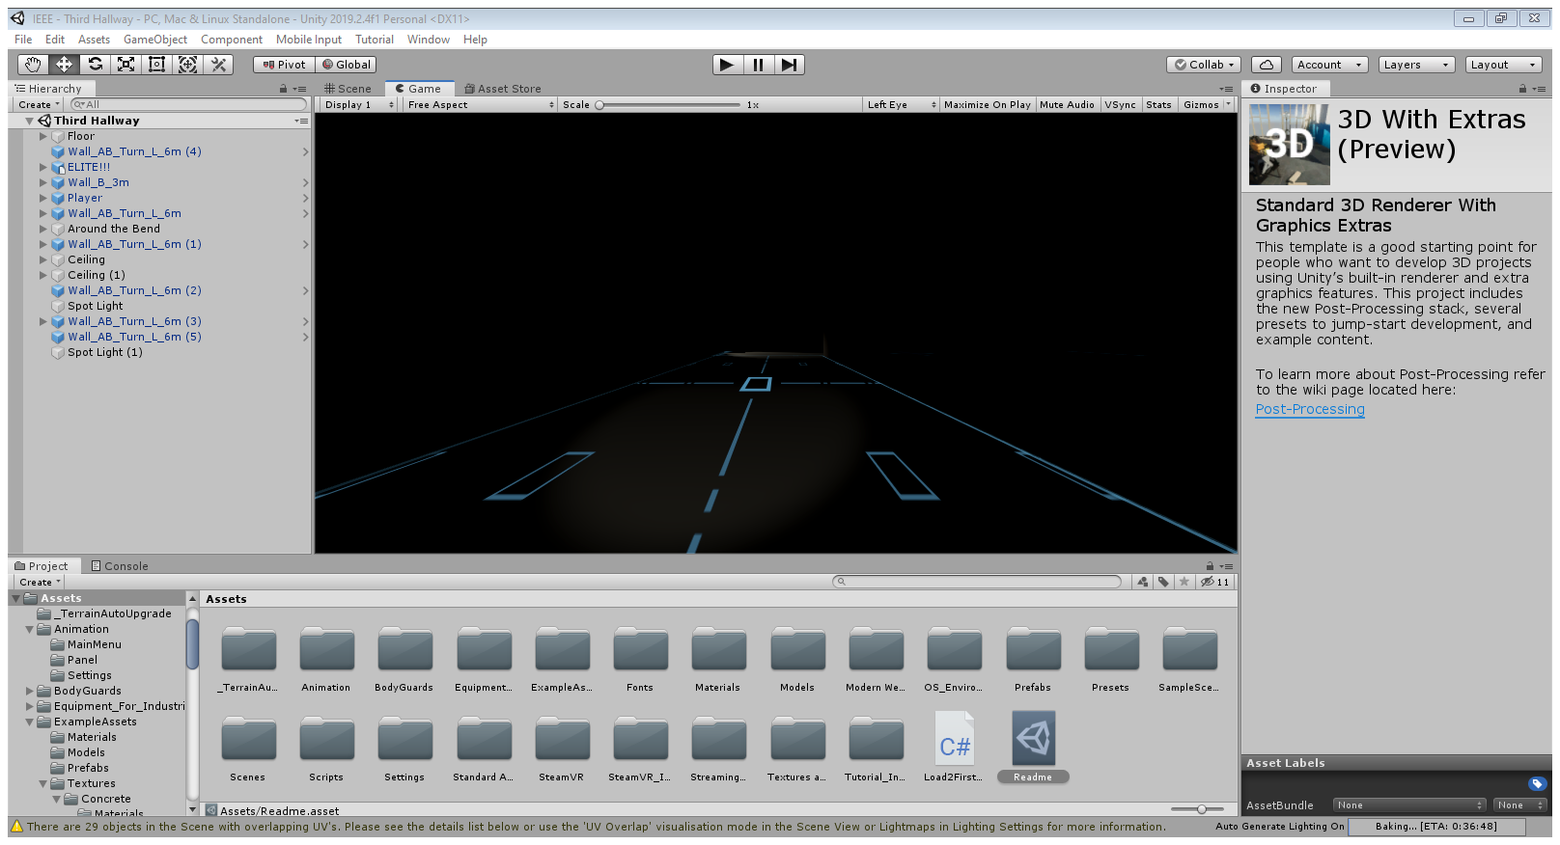

Figure - Third Hallway

### Implementation of Subtask 2C

As mentioned in the above section, this game has 5 hallways. This subtask will implement the final two hallways the player will encounter. The first one is shown below. Here, the player must teleport between chopped off sections of flooring and avoid falling to meet the past victims of this accursed hallway. Once they clear this platforming section, they are granted access to the K-Map puzzle.

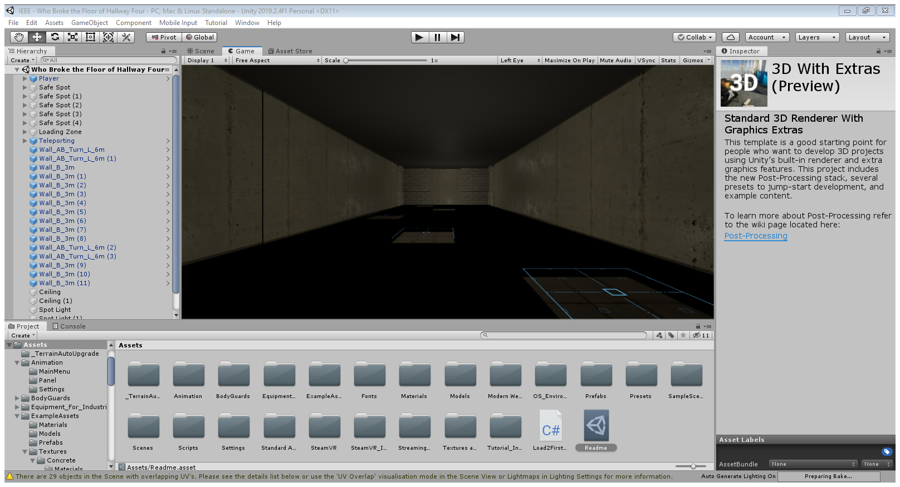

Figure - Broken 4th Hallway

The last hallway is not yet implemented in Unity; however, the idea is still worth mentioning. This hallway will be layered and utilizing the teleportation feature to get from the lower level to a higher level. This hallway will also introduce the elite security force who will stop at nothing to stop the player.

1. Conclusion (Discussion and Future Plans)

By the end of the project, conclude the project and your learning experience.

Acknowledgment

If you get help or support from someone else (besides the team member and the advisor) and want to show your appreciation, put here (**do not include the advisor**).

Appendix

You can put reference info here, including: i) specs of components used in the system, ii) source code (must be here but not in the body text), iii) CAD figures, etc.

1. Component Specs
2. Specs of Arduino Due

...

1. Specs of Raspberry Pi

…

1. Source Code.
2. Source Code of Graphic User Interface

…

1. Source Code of Robotic Arm

…

REFERENCES

[1] D. Vantrease, R. Schreiber, M. Monchiero, M. McLaren, N. P. Jouppi, M. Fiorentino*, et al.*, "Corona: System Implications of Emerging Nanophotonic Technology," in *Computer Architecture, 2008. ISCA '08. 35th International Symposium on*, 2008, pp. 153-164.

[2] X. Zhang and A. Louri, "A multilayer nanophotonic interconnection network for on-chip many-core communications," in *Design Automation Conference (DAC), 2010 47th ACM/IEEE*, 2010, pp. 156-161.

[3] C. Batten, A. Joshi, J. Orcutt, A. Khilo, B. Moss, C. Holzwarth*, et al.*, "Building manycore processor-to-DRAM networks with monolithic silicon photonics," in *High Performance Interconnects, 2008. HOTI '08. 16th IEEE Symposium on*, 2008, pp. 21-30.

[4] Y. Pan, P. Kumar, J. Kim, G. Memik, Y. Zhang, and A. Choudhary, "Firefly: illuminating future network-on-chip with nanophotonics," in *IEEE/ACM Intl. Symp. on Computer Architecture (ISCA)*, 2009, pp. 429-440.

[5] N. Kirman, M. Kirman, R. K. Dokania, J. F. Martinez, A. B. Apsel, M. A. Watkins*, et al.*, "Leveraging Optical Technology in Future Bus-based Chip Multiprocessors," in *Microarchitecture, 2006. MICRO-39. 39th Annual IEEE/ACM International Symposium on*, 2006, pp. 492-503.

[6] J. M. Cianchetti, C. J. Kerekes, and H. D. Albonesi, "Phastlane: a rapid transit optical routing network," in *Proceeding of: 36th International Symposium on Computer Architecture (ISCA)*, 2009, pp. 441-450.

[7] A. Shacham, K. Bergman, and L. P. Carloni, "Photonic Networks-on-Chip for Future Generations of Chip Multiprocessors," *Computers, IEEE Transactions on,* vol. 57, pp. 1246-1260, 2008.

[8] A. Shacham, K. Bergman, and L. P. Carloni, "On the Design of a Photonic Network-on-Chip," in *First International Symposium on Networks-on-Chip, 2007. NOCS 2007*, 2007, pp. 53-64.

[9] M. Kwai Hung, Y. Yaoyao, W. Xiaowen, Z. Wei, L. Weichen, and X. Jiang, "A Hierarchical Hybrid Optical-Electronic Network-on-Chip," in *VLSI (ISVLSI), 2010 IEEE Computer Society Annual Symposium on*, 2010, pp. 327-332.

[10] D. Ding and D. Z. Pan, "OIL: a nano-photonics optical interconnect library for a new photonic networks-on-chip architecture," presented at the Proceedings of the 11th international workshop on System level interconnect prediction, San Francisco, CA, USA, 2009.

[11] A. Joshi, C. Batten, K. Yong-Jin, S. Beamer, I. Shamim, K. Asanovic*, et al.*, "Silicon-photonic clos networks for global on-chip communication," in *Networks-on-Chip, 2009. NoCS 2009. 3rd ACM/IEEE International Symposium on*, 2009, pp. 124-133.

[12] D. Vantrease, R. Schreiber, M. Monchiero, M. McLaren, N. P. Jouppi, M. Fiorentino*, et al.*, "Corona: system implications of emerging nanophotonic technology," in *Proc. 35th IEEE/ACM Int'l Symp. Computer Architecture (ISCA)*, 2008, pp. 153-164.

[13] L. Zhang, E. Regentova, and X. Tan, "A 2D-Torus Based Packet Switching Optical Network-on-Chip Architecture," presented at the *IEEE International Symposium on Photonics and Optoelectronics* (SOPO 2011), Wuhan, China, 2011.

[14] L. Zhang, E. E. Regentova, and X. Tan, "Packet switching optical network-on-chip architectures," *Comput. Electr. Eng.,* vol. 39, pp. 697-714, 2013.

[15] G. Huaxi, X. Jiang, and W. Zheng, "A novel optical mesh network-on-chip for gigascale systems-on-chip," in *Circuits and Systems, 2008. APCCAS 2008. IEEE Asia Pacific Conference on*, 2008, pp. 1728-1731.

[16] G. Huaxi, X. Jiang, and Z. Wei, "A low-power fat tree-based optical Network-On-Chip for multiprocessor system-on-chip," in *Design, Automation & Test in Europe Conference & Exhibition, 2009. DATE '09.*, 2009, pp. 3-8.

[17] Y. Yaoyao, X. Jiang, H. Baihan, W. Xiaowen, Z. Wei, W. Xuan*, et al.*, "3-D Mesh-Based Optical Network-on-Chip for Multiprocessor System-on-Chip," *Computer-Aided Design of Integrated Circuits and Systems, IEEE Transactions on,* vol. 32, pp. 584-596, 2013.

[18] A. Shacham, K. Bergman, and L. P. Carloni, "Photonic networks-on-chip for future generations of chip multiprocessors," *IEEE Trans. Computers,* vol. 57, pp. 1246-1260, 2008.

[19] A. W. Poon, F. X. Xu, and X. Luo, "Cascaded active silicon microresonator array cross-connect circuits for WDM networks-on-chip," in *Proc. SPIE*, 2008, p. 689812.

[20] M. Lipson, "Compact Electro-Optic Modulators on a Silicon Chip," *IEEE Journal of Selected Topics in Quantum Electronics,* vol. 12, pp. 1520-1526, 2006.

[21] M. Lipson, "Guiding, modulating, and emitting light on Silicon-challenges and opportunities," *Lightwave Technology, Journal of,* vol. 23, pp. 4222-4238, 2005.

[22] T. Xianfang, Y. Mei, Z. Lei, J. Yingtao, and Y. Jianyi, "Wavelength-routed optical networks-on-chip built with comb switches," in *Photonics Conference (IPC), 2013 IEEE*, 2013, pp. 46-47.